**Advanced Grouping tasks – Reports**

Task 03. CREATE Test AdHoc SQL - Monthly Reports (CUBE)

Layout presented in attached file WB_funding_monthly.xlsx was created for monthly report. To calculate data for the report were used:

* CUBE Extension;
* Grouping() function;
* Grouping_ID function.

Script is contained in attached file WB_Funding_monthly.sql.

The script result is presented below.

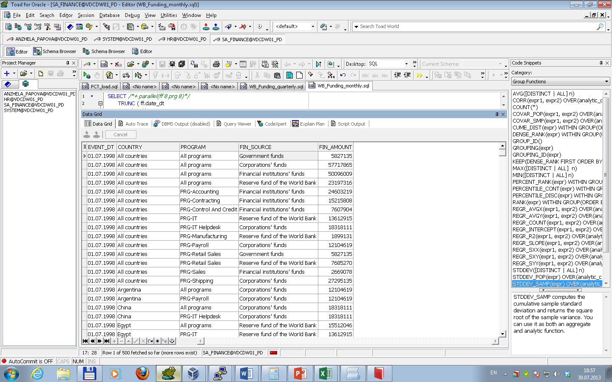

As shown above data structure of script result satisfies to layout requirements.

Task 04. CREATE Test AdHoc SQL - Quarterly Reports (ROLLUP & GROUPING SETS)

Layout presented in attached file WB_funding_quarterly.xlsx was created for quarterly report. To calculate data for the report were used:

* ROLLUP Extension;
* Grouping() function.

Script is contained in attached file WB_Funding_quarterly.sql.

The script result is presented below.

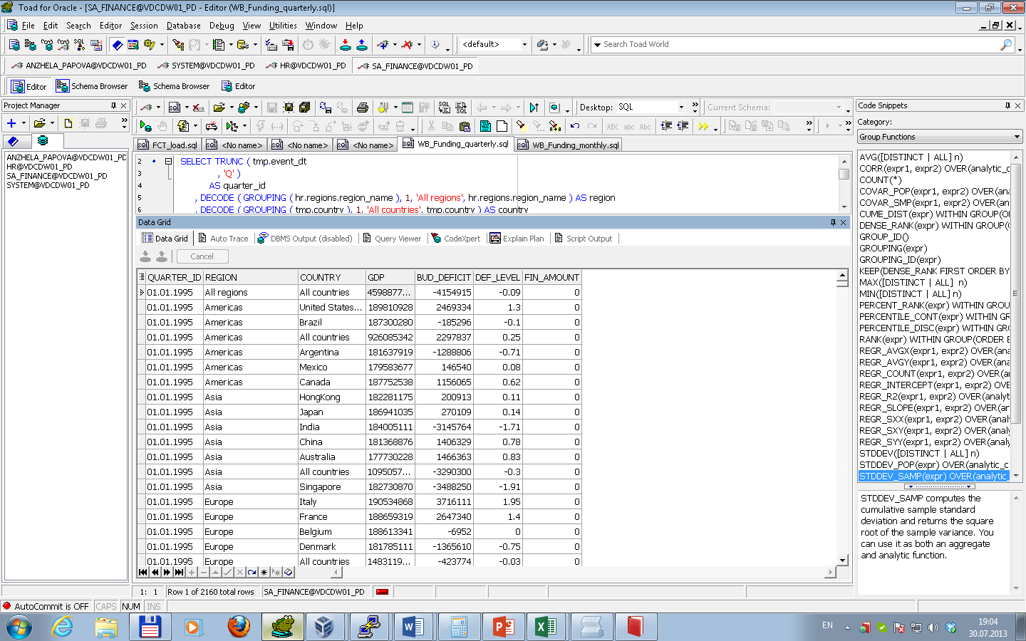

As shown above data structure of script result satisfies to layout requirements.

Task 05: CREATE Test AdHoc SQL – ROLLUP by Time

To calculate data for the report were used:

* ROLLUP Extension;
* Grouping() function.

Script is contained in attached file WB_Funding_rollup_time.sql.

The script result is presented below.

